Smaointí Oibre do Rang 2: 3/6/2020 – 5/6/2020
Gaeilge: Mé Féin (Myself)
- Féach ar Cúla 4 ar Scoil (Luan – Aoine @ 10 a chlog ar TG4) nó am ar bith ag an nasc seo:
https://www.tg4.ie/en/player/categories/childrens-tv-shows/?series=C%C3%BAla4%20Ar%20Scoil&genre=Cula4

- Bí ag caint sa bhaile. Déan cur síos ort féin.
Ansin, líon isteach “Próifíl: Mé Féin” ag bun an doiciméid seo.
(Describe yourself. Fill in the Profile at the bottom of this document.)

- Léigh agus pléigh an dán thíos. (Read & discuss the poem below.)

Seáinín Bocht

Tá pian i mo lámha,a mhúinteoir,a mhúinteoir. Tá pian i mo lámha; Ní féidir liom scríobh.

Ní féidir leat scríobh,a Sheáinín,a Sheáinín? Ní féidir leat scríobh ?... An féidir leat léamh?

Tá pian i mo shúile, a mhúinteoir,a mhuinteoir. Tá pian i mo shúile; Ní féidir liom léamh.

Ní féidir leat léamh, a Sheáinín,a Sheáinín Ní féidir leat léamh?... An féidir leat éisteacht?

Tá pian i mo chluasa,a mhúinteoir,a mhúinteoir. Tá pian i mo chluasa; Ní féidir liom éisteacht.

Ní féidir leat éisteacht, a Sheáinín,a Sheáinín? Ní féidir leat éisteacht?... An féidir leat ithe ?

Is féidir liom ithe, a mhúinteoir,a mhúinteoir. Ba bhreá liom seacláid,milseáin,líomanáid.
Bá bhreá liom seacláid,milseáin,líomanáid!

Le Dominic Ó Braonáin

Obair Breise/Extra Work: Léigh “Mé Féin” ag an nasc seo:
https://www.cogg.ie/wp-content/uploads/20.M%C3%A9-F%C3%A9in-asal.pdf
Matamaitic: Meáchan (Weight)
Pléigh meachán rudaí éagsúla sa bhaile. Cur rudaí áirithe i gcomparáid lena chéile. Cinntigh cén rud atá níos troime, cén rud atá níos éadroime agus aimsigh rudaí atá thart ar an meáchan céanna.
Discuss the weight of various items at home. Compare items to one another. Decide which item is heavier, which item is lighter and then find items that are around the same weight.
An cileagram (Kilogram)
Faigh rud sa bhaile atá 1 kg, mála siúcra mar shampla. Pioc suas é agus mothaigh cé chomh trom atá 1kg!! Ansin, téigh timpeall an tí ag piocadh suas agus ag cur rudaí eile i gcomparáid le 1kg. Cinntigh an bhfuil na rudaí eile níos troime, níos éadroime nó thart timpeall ar 1kg.
Find something at home that weighs 1kg, eg. a bag of sugar. Pick it up and feel how heavy 1kg is!!
Then pick up and compare other items in your house to 1 kg. Decide if these items are heavier, lighter or if they weigh approx. 1 kg.

Gníomhaí deasa arlíne ag na nascanna thíos (Some interactive weight activities at the links below:)
http://data.cjfallon.ie/resources/19626/activity-104/index.html
http://data.cjfallon.ie/resources/19626/activity-105/index.html
http://data.cjfallon.ie/resources/19626/activity-106/index.html
http://data.cjfallon.ie/resources/19626/activity-107/index.html

- Déan Gafa le Mata L. 104, 106, 107.
(The online English version of this book “Busy at Maths 2” is available to view at: https://www.cjfallon.ie/)

- Téigh Siar ar na Táblaí Dealú: -1, -2, -3, -4, -5
Téigh go L.4 anseo https://educate.ie/bookpreview/seaimp%C3%ADn-na-dt%C3%A1bla%C3%AD-second-class

O.S.P.S: Sábháilteacht Uisce (Water Safety)
Pléigh Sábhailteacht Uisce. Úsáid na nascanna thíos. (Discuss Water Safety. Use the links below.)
https://online.flowpaper.com/7efd0784/PAWS2ENGLISHWEB/#page=1
http://paws.edco.ie/first-and-second-classes/

Ealaín: Péint agus Dath (Paint and Colour)
Bí cruthaitheach le péint nó le dathanna sa bhaile. Be creative with paint or colours at home.
Féach ar an bhfíseán seo le haghaidh roinnt smaointe. Look at this video for ideas & inspiration.
https://www.youtube.com/watch?v=H_YmPmX6tnU
English
- Read and discuss the poem below.
You can also read more poetry and children’s writing about the corona virus experience at the link to this article below.
https://www.irishtimes.com/culture/staying-inside-children-write-about-their-coronavirus-experience-1.4226127
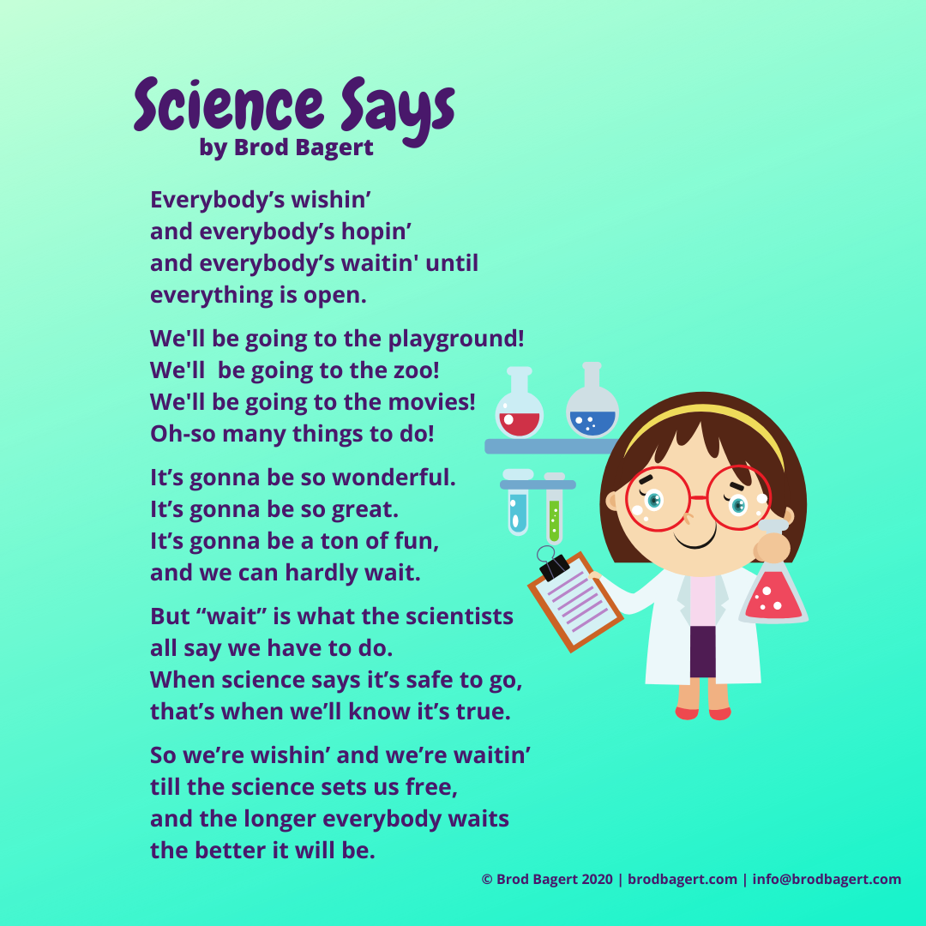

- Write your own poem.
You can write any type of poem you like eg. serious, silly, sad, happy, funny, rhyming or not rhyming, an Acrostic Poem, a Shape Poem, etc. Enjoy being creative and coming up with your very own poem.
(Obair Breise/Extra Work)

- Continue with the 20 Book Reading Challenge: I would love to know how you are all getting on with this challenge!! You can email me a list of books you’ve read or send your Challenge Sheet to: clair@scoilnagceithremaol.com
(online links to help you): https://rivet.area120.com/read/#/libraryScreen
https://www.storyberries.com/, https://www.worldbook.com/ebooks.aspx
https://stories.audible.com/start-listen, http://www.storylineonline.net/
http://www.storylineonline.net/

- Free Writing – Write about anything you like in any genre/format you like.

(English) Next Week: Our class will begin to read “Fantastic Mr.Fox” by Roald Dahl next week & we will base some lessons on this book over the next few weeks. If you happen to have a copy of this book at home or if you know someone that could lend you the book, that’s great. However, you do not need to buy this book, as I will send you a link to download the story and you can read it online or print off a few chapters.

Ceol: Feadóg Stáin (Tin Whistle): Cleachtaigh na nótaí.

Aclaíocht Laethúil (Daily Outdoor Exercise):
Imir Cleas na Bacóide lasmuigh. Play Hopscotch outside.
Tá treoracha & smaointe eile ar fáil ag na nascanna seo. Instructions & other ideas available at these links.
Gaeilge: https://static.rasset.ie/documents/learn/2020/04/ga-worksheet-1-2-wed29-pe.pdf
Béarla: https://www.rte.ie/learn/2020/0427/1135135-1st-2nd-class-pe/

Próifíl: Mé Féin
__________________________________ is ainm dom.
Tá gruaig ________________________________ orm.
Tá súile _______________________________ agam.
Tá mé i mo chónaí i ______________________________________.
Tá mé _________________ mbliana d’aois.
Tá mo bhreithlá ar an _______ lá de mhí _______________________.
Táim i Rang a _______________.
Tá ________________________ i mo chlann.
Tá ________ deirfúir agam agus __________ deartháir agam.
Oibríonn mo mháthair ____________________________________.
Oibríonn m’athair _______________________________________.
Nuair a bheidh mé fásta suas, ba mhaith liom a bheith i mo _____________.
‘Sé an clár teilifíse is fearr liom ná ______________________________.
‘Sé an bia is fearr liom ná _____________________________________.
‘Sé an cluiche/spórt is fearr liom ná _____________________________.
*Focail ag an nasc thíos chun cabhrú leat:
https://www.scoilnet.ie/uploads/resources/6230/6039.pdf

*Focail eile chun cabhrú leat:
Dath na gruaige: gruaig dhubh, gruaig dhonn, gruaig fhionn, gruaig rua.
Dath na súl: súile glasa, súile gorma, súile donna.
Uimhreacha Pearsanta: aon _____ amháin, beirt, triúr, ceathrar, cúigear, seisear, seachtar, ochtar.
Dátaí: an chéad lá, an dara lá, an triú lá, an ceathrú lá, an cúigiú lá, an séú lá, an seachtú lá, an t-ochtú lá,
an naoú lá, an deichiú lá, an taonú lá déag, an dara lá déag, An tríú lá déag, An ceathrú lá déag, An cúigiú lá déag,
An séú lá déág, An seachtú lá déag, An t-ochtú lá déag, An naoú lá déag, An fichiú lá, An t-aonú lá is fiche,
An dara lá is fiche, An tríú lá is fiche, An ceathrú lá is fiche, An cúigiú lá is fiche, An séú lá is fiche,
An seachtú lá is fiche, An t-ochtú lá is fiche, an naoú lá is fiche, An tríochú lá, An t-aonú lá is tríocha.

Na Míonna: 1. Mí Eanáir 2. Mí Feabhra 3. Mí an Mhárta 4. Mí Aibreáin 5. Mí na Bealtaine 6. Mí an Mheithimh
7. Mí Iúil 8. Mí Lúnasa 9. Mí Mheán Fómhair 10. Mí Dheireadh Fómhair 11. Mí na Samhna 12. Mí na Nollag

