A chairde,
Tá súil agam go bhfuil sibh go maith. Seo chugaibh roinnt smaointe oibre don tseachtain. Ná bígí faoi bhrú gach rud a dhéanamh. Pioc amach na rudaí a oireann le do theach agus le do pháiste. Má tá ceist ar bith agat, nó má tú ag lorg obair breise, tar i dteagmháil liom ag scoilgael@gmail.com
I hope you are all well. These are some learning ideas for the week. Please do not be under pressure to do everything on the list. Select the ideas that suit your house and your child. If you have any questions, or if you would like extra work, please feel free to contact me at scoilgael@gmail.com
Míle Buíochas, Múinteoir Clár.
Eolas/Information: Tacaíocht ar an Teilifís
Beidh clár nua “Cúla 4 ar Scoil” ag tosú ar TG4 ar an Luan, an 20 Aibreán, ag a 10 a.m nó ar cula4.com. Beidh an clár seo dírithe ar dhaltaí bunscoile Gaeltachta agus Gaelscoile. Beidh sceideal breise á chraoladh ag TG4 roimh agus i ndiaidh Cúla4 ar Scoil ó 9:30 a.m. go 11 a.m. gach lá, mar a mbeidh cláir eile a bhfuil téamaí oideachasúla ag baint leo, macasamhail ‘Bia Linn’, ‘Ár Scéal’, ‘Am Foghlama le Timmy’, ‘Is Eolaí Mé’ agus ‘WAC’. Chomh maith le sin tá RTE ag leanacht ar aghaidh le ceachtanna ar RTE Home School Hub ar RTE2 ag a 11am nó ar RTE Player. B’fhiú am a chaitheamh ag féachaint ar roinnt de na ceachtanna má oireann sé libh.
A new programme “Cúla 4 ar Scoil” will commence Monday 20 April 2020, broadcasting weekdays at 10a.m. Also available at cula4.com. This programme will cater for primary school children who attend Gaelscoileanna and Gaeltacht schools. TG4 will also broadcast an additional schedule before and after Cúla4 ar Scoil from 9:30 a.m. to 11 a.m. each day, which will include programmes with educational themes including ‘Bia Linn’, Ár Scéal, ‘Am Foghlama le Timmy’, ‘Is Eolaí Mé’ and ‘WAC’.
In addition to this, RTE are continuing with RTE Home School Hub lessons on RTE2 at 11am or on RTE Player. It would be worthwhile watching some of these lessons if it suits.
Smaointí Oibre do Rang 2: 20/4/2020 – 24/4/2020
Gaeilge: An Teilifís (Theme- Television)
- Féach ar Cúla 4 ar Scoil (Luan – Aoine @ 10 a chlog ar TG4) nó am ar bith ag an nasc seo:
https://www.tg4.ie/en/player/categories/childrens-tv-shows/?series=C%C3%BAla4%20Ar%20Scoil&genre=Cula4
- Bí ag caint le do theaghlach faoin teilifís. Scríobh cúpla líne faoin gclár teilifíse is fearr leat.
(Talk to your family about Television. Write a few lines as Gaeilge about your favourite programme.)
Nascanna chun cabhrú libh. https://www.scoilnet.ie/uploads/resources/30020/29756.pptx
https://www.scoilnet.ie/uploads/resources/23537/23260.pdf
- “Léigh sa Bhaile” Léigh leathanach ar bith gach lá
- Litrigh É Linn L.25, 26 (Foghlaim na litriú)
- Léigh agus pléigh an dán thíos.
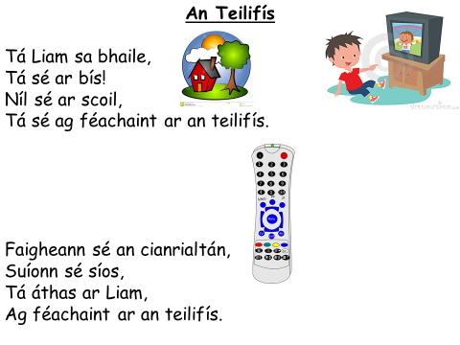
- Obair Breise/Extra Work: Léigh an scéal seo: http://robo.ie/PictiurlannBileogOibre.pdf,
Éist leis an scéal ag/Listen to this story: robo.ie, cliceáil Bunleibhéal, ansin cliceáil 5.An Phictiúrlann, ansin cliceáil Éist.
Matamaitic: Topaic = Am (Time)
- Féach ar cloganna analóige agus digiteacha go rialta. Cleachtaigh ag insint ama ar uair agus ar leathuair agus ar ceathrú uair an chloig. B’fhéidir buail do bhosa ar gach uair a chloig agus gread do chosa ar gach leathuair an chloig. Cuir lámh amháin amach ar thaobh amháin ag ceathrú tar éis agus cuir an lámh eile amach ar an taobh eile ag ceathrú chun.
Pléigh cén t-am a bhí ann uair an chloig níos luaithe agus uair an chloig níos déanaí.
Ansin pléigh cén t-am a bhí ann leathuair an chloig níos luaithe agus leathuair an chloig níos déanaí
Cleachtaigh ag scríobh na hamantaí go digiteach.

Féach ar an sceideal teilifíse. Pléigh ord agus amantaí na cláir. Cuir ceisteanna ar nós:
Cén clár a bheidh ar siúl uair an chloig roimh an Nuacht? cén clár a bheidh ar siúl leathuair an chloig tar éis tús na Nuachta?
Look at analogue and digital clocks regularly. Practise telling time on the hour and on the half hour and on the quarter hour. Maybe you could clap your hands on the stroke of every hour and stamp your feet on the stroke of every half hour. Put one arm out to your side at quarter past and put your other arm out to the side at quarter to. Discuss what time it was an hour ago and what time it will be an hour from now. Discuss what time it was half an hour ago and what time it will be half an hour from now.
Practise writing the times digitally.
Look at the TV Schedule. Discuss the order and the times of the programmes. Ask questions such as: Which programme will be on 1 hour before the News? Which Programme will be on half an hour after the start of the News?
Nascanna ar líne chun cabhrú leat (online links to help you):
https://static.rasset.ie/documents/learn/2020/04/en-worksheet-5-6-friday-10-gaeilge.pdf
http://www.snappymaths.com/other/measuring/time/interactive/halfhours/oclockhpimm/oclockhpimm.htm
https://www.primarygames.com/time/4a.htm
https://mathsframe.co.uk/en/resources/resource/116/telling_the_time#
(Click Play. Select: 3. Read time to the quarter hour. Tick 12 hour clock.)

- Gafa le Mata L.118, 119, 120, 121.
Uair an chloig níos luaithe = 1 hour earlier, uair an chloig níos déanaí = 1 hour later
(½) leath uair an chloig níos luaithe = ½ hour earlier, (½) leath uair an chloig níos déanaí = ½ hour later
(¼) ceathrú tar éis = quarter past. (¼) ceathrú chun = quarter to.
Tosaíonn …. ag = Starts at, díreach tar éis = immediately after, díreach roimh = immediately before,
aon Uair an chloig tar éis = 1 hour after. aon Uair an chloig roimh = 1 hour before. Leathuair = half an hour.

- Matamaitic: Topaic = Féilire (Calendar)
Téigh siar ar séasúir agus míonna na bliana as Gaeilge agus as Béarla. (Féach ar Gafa le Mata L.77)
Féach ar féilire sa bhaile. Aimsigh Mí Aibreáin. Faigh amach – Cé mhéad lá atá i mí Aibreáin?
Cén lá a thit an 1ú Aibreán ar? An bhfuil ainm speisialta eile ar an lá seo??
Cén dáta a thit Domhnach na Cásca ar? An bhfuil dátaí speisialta eile i Mí Aibreáin?
Cé mhéad Céadaoin atá i Mí Aibreáin?
Cen dáta é an lá deireanach i Mí Aibreán? Cén lá é sin? Cén lá é an 1ú Bealtaine?

Revise the seasons and months of the year as Gaeilge and in English.
Look at a calendar. Find the month of April. Find out – How many days are in April?
What day did the 1st of April fall on? Is there another special name for this day??
What date did Easter Sunday fall on? Are there other special dates in April?
How many Wednesdays are in April?
What date is the last day of April? What day is this? What day is the 1st May on?
- Gafa le Mata L.75 & 76

Obair Breise/Extra Work
- Mata Meabhrach – Lean ar aghaidh sa leabhar seo. Déan an méid “Triail” gur mhaith leat. Continue working in this book. Complete as many “Triail” as you like.
- Dúshlán Breise??? Want an extra challenge in Maths???
Consider signing up to Khan Academy (Roghnaigh/Select Grade 2 activities)
https://www.khanacademy.org/signup

Creideamh: Féach ar na físeáin agus pléigh Bás & Aiséirí Íosa:
(As Gaeilge - https://vimeo.com/196906068, & https://vimeo.com/196906090)
Watch these videos and discuss the Death and Resurrection of Jesus:
(English Versions- https://vimeo.com/171914911, & https://vimeo.com/171909572)

Eolaíocht/Tíreolaíocht: Na hÉin (Birds)
Téigh amach ag cuardach éin sa ghairdín/lasmuigh. Ainmnigh iad más féidir leat & tarraing pictiúir.
Go outside searching for birds. Name them if you can and draw pictures. Links to help below.
https://content.twinkl.co.uk/resource/d6/cb/ROI-T-076-Irish-Birds-Display-Photos-Gaeilge.pdf?__token__=exp=1587340451~acl=%2Fresource%2Fd6%2Fcb%2FROI-T-076-Irish-Birds-Display-Photos-Gaeilge.pdf%2A~hmac=3d37c299a8bd5ee6ecc40a36fa0bd48fb2a8a0f01b6cb3a6aea10154bebe0709
https://content.twinkl.co.uk/resource/0e/fb/T-T-17664-Garden-Birds-Sighting-Checklist.pdf?__token__=exp=1587340618~acl=%2Fresource%2F0e%2Ffb%2FT-T-17664-Garden-Birds-Sighting-Checklist.pdf%2A~hmac=59482be94c58320505f58b929febde320cbb630e251294a6fbaf1766ddf8c57a
Léigh faoin bhfáinleog (swallow) anseo. https://www.cogg.ie/wp-content/uploads/8.An-Fh%C3%A1inleog-b%C3%A9ar.pdf

Aclaíocht Laethúil (Daily Outdoor Exercise): Téigh amach ag spraoi/ar siúlóid chomh minic & is féidir.
Laistigh (Indoor ideas):Cliceáil ar Corpoideachas le Ciarán https://www.youtube.com/user/YogaAsGaeilge

Béarla & S.P.H.E. & Ealaín: Fógraíocht (Advertising) Féach ar na 2 físeáin seo/Look at these 2 videos:
https://www.safefood.eu/Education/Primary-(ROI)/MediaWise/Who_is_the_Target_j_s.aspx
https://www.safefood.eu/Education/Primary-(ROI)/MediaWise/Medias_influence_j_s.aspx
Discuss advertising on the TV and in the media. Design & make a poster advertising a toy. Draw a very flattering picture of the toy and write amazing things about it. You are trying to convince people to buy it!!
Béarla continued:
- My Spelling Workbook – Unit 14 Learn spellings & complete activities.
- 20 Book Reading Challenge! Write & keep a list of everything you read over the next few weeks. Print/Write out the challenge below. Tick off 1 relevant box after you read a book (paper or e-book). You may only tick 1 box per book. Let’s see how many boxes you can tick before the summer!! Best of luck
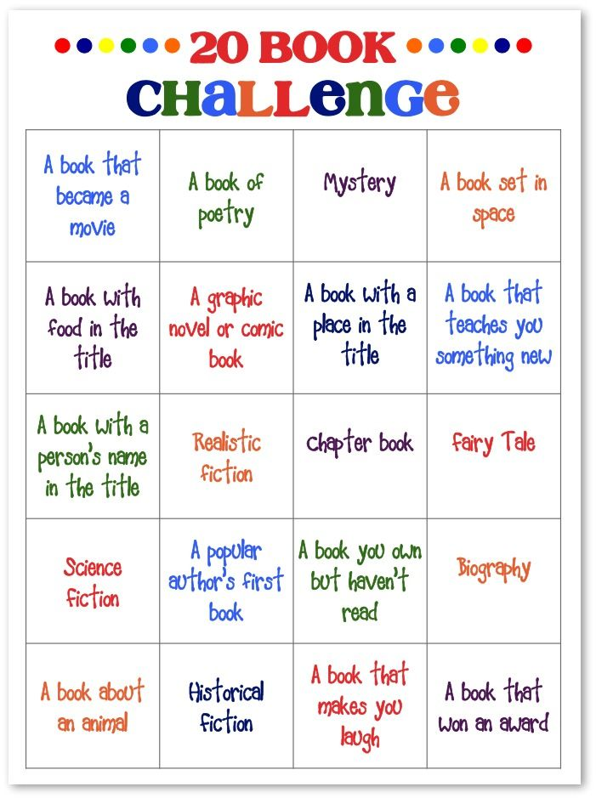

Nascanna ar líne chun cabhrú leat- online links to help you ...
https://rivet.area120.com/read/#/libraryScreen
https://www.storyberries.com/
https://www.worldbook.com/ebooks.aspx
https://stories.audible.com/start-listen
http://www.storylineonline.net/

