Dé Luain
Rang 3
Mata
Lgh 15&16
https://my.cjfallon.ie/preview/student/21717/21

Táblaí x9 agus ÷9

Gaeilge
Taisce Tuisceana
https://www.cogg.ie/wp-content/uploads/10.An-frog-béar.pdf

Léigh sa Bhaile lch amháin

Béarla
Better English lch113
https://educateplus.ie/ppresource/better-english-3rd-class

Cúla4 ar Scoil - TG4 @10:00 – 10:30
Ná déanaigí dearmad breathnú ar Cúla4 ar Scoil @10 https://www.cula4.com/en/shows/cula4-ar-scoil/

Sos Gníomhach - Seachtain Ghníomhach sa Bhaile
https://activeschoolflag.ie/index.php/active-home-week-2020/

RTÉ Home at School - RTÉ2 @11:00 - 12:00
Chomh maith le sin beidh RTÉ Home at School ar siúl @11 ar RTÉ2. Breathnaigí ar https://www.rte.ie/learn/3rd-and-4th-class/?page=1
chun na bileog oibre a théann leis na ceachtanna a fháil.

Seo a leanas roinnt smaointe d’Ionadluach./ The following contains some ideas for Place Value.

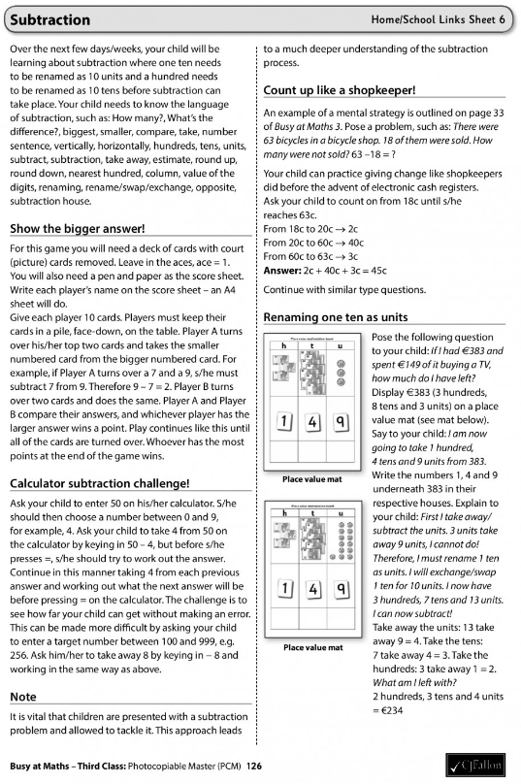
Dé Máirt
Rang 3
Mata
Lgh 17&18
https://my.cjfallon.ie/preview/student/21717/21

Táblaí x10 agus ÷10

Gaeilge
Taisce Tuisceana
https://www.cogg.ie/wp-content/uploads/11.Bí-sláintiúil-béar.pdf

Léigh sa Bhaile lch amháin

Béarla
Better English lch114
https://educateplus.ie/ppresource/better-english-3rd-class

Cúla4 ar Scoil - TG4 @10:00 – 10:30
Ná déanaigí dearmad breathnú ar Cúla4 ar Scoil @10 https://www.cula4.com/en/shows/cula4-ar-scoil/

Sos Gníomhach - Seachtain Ghníomhach sa Bhaile
https://activeschoolflag.ie/index.php/active-home-week-2020/

RTÉ Home at School - RTÉ2 @11:00 - 12:00
Chomh maith le sin beidh RTÉ Home at School ar siúl @11 ar RTÉ2. Breathnaigí ar https://www.rte.ie/learn/3rd-and-4th-class/?page=1
chun na bileog oibre a théann leis na ceachtanna a fháil.

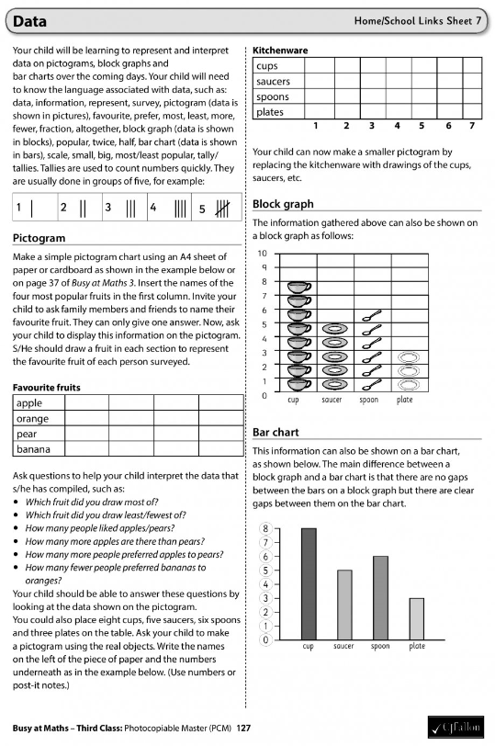

Dé Céadaoin
Rang 3
Mata
Lgh 19&20
https://my.cjfallon.ie/preview/student/21717/21

Táblaí x11 agus ÷11

Gaeilge
Taisce Tuisceana
https://www.cogg.ie/wp-content/uploads/12.Lusanna-gréine-béar.pdf

Léigh sa Bhaile lch amháin

Béarla
Better English lch115
https://educateplus.ie/ppresource/better-english-3rd-class

Cúla4 ar Scoil - TG4 @10:00 – 10:30
Ná déanaigí dearmad breathnú ar Cúla4 ar Scoil @10 https://www.cula4.com/en/shows/cula4-ar-scoil/

Sos Gníomhach - Seachtain Ghníomhach sa Bhaile
https://activeschoolflag.ie/index.php/active-home-week-2020/

RTÉ Home at School - RTÉ2 @11:00 - 12:00
Chomh maith le sin beidh RTÉ Home at School ar siúl @11 ar RTÉ2. Breathnaigí ar https://www.rte.ie/learn/3rd-and-4th-class/?page=1
chun na bileog oibre a théann leis na ceachtanna a fháil.

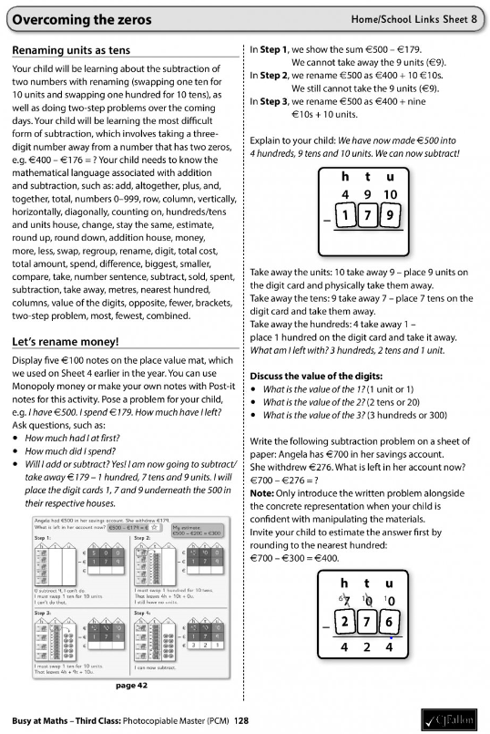

Déardaoin
Rang 3
Mata
Lgh 21&22
https://my.cjfallon.ie/preview/student/21717/21

Táblaí x12 agus ÷12

Gaeilge
Taisce Tuisceana
https://www.cogg.ie/wp-content/uploads/13An-seilide-béar.pdf

Léigh sa Bhaile lch amháin

Béarla
Better English lch116
https://educateplus.ie/ppresource/better-english-3rd-class

Cúla4 ar Scoil - TG4 @10:00 – 10:30
Ná déanaigí dearmad breathnú ar Cúla4 ar Scoil @10 https://www.cula4.com/en/shows/cula4-ar-scoil/

Sos Gníomhach - Seachtain Ghníomhach sa Bhaile
https://activeschoolflag.ie/index.php/active-home-week-2020/

RTÉ Home at School - RTÉ2 @11:00 - 12:00
Chomh maith le sin beidh RTÉ Home at School ar siúl @11 ar RTÉ2. Breathnaigí ar https://www.rte.ie/learn/3rd-and-4th-class/?page=1
chun na bileog oibre a théann leis na ceachtanna a fháil.

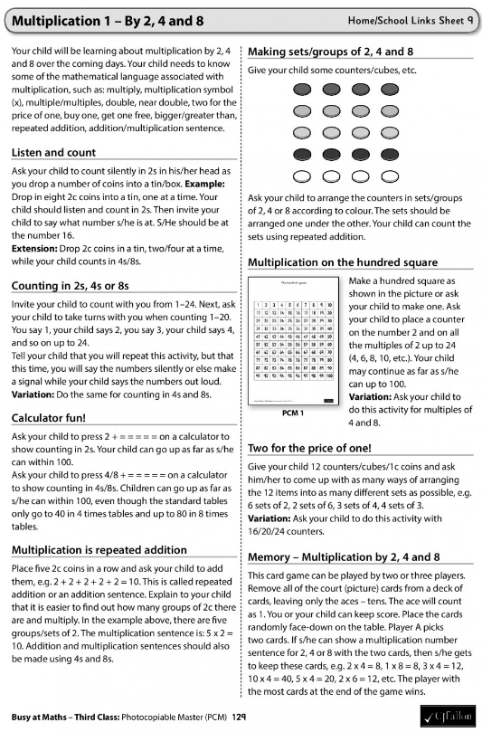

Dé hAoine
Rang 3
Mata
Lgh 23&24
https://my.cjfallon.ie/preview/student/21717/21

Táblaí: Dul Siar

Gaeilge
Taisce Tuisceana
https://www.cogg.ie/wp-content/uploads/14.An-phiongain-béar.pdf

Léigh sa Bhaile lch amháin

Béarla
Better English lch117
https://educateplus.ie/ppresource/better-english-3rd-class

Cúla4 ar Scoil - TG4 @10:00 – 10:30
Ná déanaigí dearmad breathnú ar Cúla4 ar Scoil @10 https://www.cula4.com/en/shows/cula4-ar-scoil/

Sos Gníomhach - Seachtain Ghníomhach sa Bhaile
https://activeschoolflag.ie/index.php/active-home-week-2020/

RTÉ Home at School - RTÉ2 @11:00 - 12:00
Chomh maith le sin beidh RTÉ Home at School ar siúl @11 ar RTÉ2. Breathnaigí ar https://www.rte.ie/learn/3rd-and-4th-class/?page=1
chun na bileog oibre a théann leis na ceachtanna a fháil.

