Gaelscoil na gCeithre Maol,
21/08/2020
Dear Parent / Guardian, Staff Member,
RE: Drop-off and Collection Routines
The BoM and the School Leadership Team have been working to ensure a safe return to school for all pupils and staff on the 31st August. We have now finalised our plans for drop-off and collection of the children every day.
Gaelscoil na gCeithre Maol appreciates your support as we try to safely reopen the school building. If at all possible, we request you not to come onto the school grounds or into the school building unless it is essential. We appreciate that dropping off the Junior & Senior Infant pupils to the door is essential, but for the older pupils a drop off at the school gate is desirable. Working together we hope to be able to progress the reopening in as safe a manner as possible for all.
We would ask all parents to familiarise themselves with the following drop-off and collection routines for the safe delivery and collection of pupils from school. Please be patient as we endeavour to embed these necessary precautionary and protective practices at the beginning of the school year.

It is imperative that
- adults do not come within 2m of each other
- Unfortunately, parents won’t be able to have meetings with members of staff in the playground at drop-off and collection times – meetings between parents and teachers can only take place by prior arrangement. (This may have to be more restrictive depending on guidance & it is quite possible that the recommendation will be for remote meetings/telephonic communications which we are very happy to facilitate. The teacher can be contacted at the e-mail provided).
- We will be unable to release pupils at other times during the day unless the teacher has been notified in advance.
- all parents adhere to the drop-off and collection plans as outlined below:
Drop-off & Collection Plan
We intend to use three doors as points of entry & exit to the school. The children will be stewarded by a teacher to their classroom where they will wait supervised by staff until the school day starts. Each family will be assigned a door & time for arrival & exit. Please adhere to this as strictly as possible as this will allow for socially distancing. Unfortunately, there will be no cars allowed onto school grounds on the Tesco side due to the lack of space.
We will be in touch shortly with your details.

le meas,
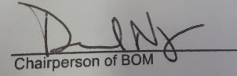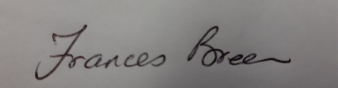
_______________________________ _____________________________
Cathaoirleach, An Bórd Bainistíochta Príomhoide

