Seachtain 30 Mí Márta- 3 Aibreán
Naíonáin Mhóra- Rang Múinteoir Arlene
A Thuistí,
Nílim ag iarraidh sibh a chur faoi bhrú leis na moltaí seo, níl ann ach smaointe. Séard é an rud is tabhachtaí go bhfuil gach duine slán agus sláintiúil. Má tá na páistí ag léamh leabhair as Béarla agus Gaeilge gach lá, ag éisteacht le scéalta, agus ag plé na scéalta sin, ag spraoi agus ag súgradh beidh mé breá sásta.
I understand that during this difficult time parents are under a lot of pressure and I really do not want to add to this, so please do not let the following recommendations be a cause of stress. The most important thing is that everyone stays safe and healthy. Children at this age learn through play so lots of imaginative play, a bit of reading every day in Irish and English, listening to and discussing stories and staying fit and active are my main recommendations.
Scileanna Saoil/ Life Skills
1 An bhfuil do pháiste ábalta barriallacha a cheangal?
Múin dóibh cén chaoi é a dhéanamh.
Can your child tie their shoelaces?
Now is a good time to teach them.
2 An bhfuil do pháiste in ann cnaipí léine a cheangal?
Múin dóibh cén chaoi é a dhéanamh.
Can your child do up shirt buttons?
Take the opportunity to practise.
3 An bhfuil do pháiste in ann cabhrú le obair an tí?
Can your child help with some housework….eg folding clothes…..weighing ingredients…….setting the table.

Ní chaithfidh tú na rudaí uilig a leanas a dhéanamh……...níl ann ach smaointe.
You do not have to do all the work outlined below. They are just suggestions if you are looking for things to do with the children.

Gaeilge
1 Cleachtaigh ceann nó dhó do na rannta atá ar eolas ag na bpáistí.
Practise one or two of the poems which your child has learned this year.
M.sh Gug a lí Gug/ Séanín ar an Rothar/ Froganna Beaga Glasa/ Ghleas Seán é féin/ Micilín Muc/ Mo mhadra/ A Phúisín/ Capall agus Bó/ Lucain Beaga.
2 Leitheoireacht: www.seideansi.ie.
Léigh na leabhair ‘Is féidir Liom’ agus ‘Na Trí Mhuicín.’ Imir na cluichí.
Treoracha le haghaidh an suíomh a úsáid sa chéad doicimeád a chur mé abhaile agus atá faoin tab, Múinteoir Arlene, ar suíomh na scoile.
Read the books ‘Is feidir Liom’ and ‘Na Trí Mhuicín.’ Play the games which go with the books.
I already sent home instructions about how to access the books on this website. This document should also be available under my tab on the school website.

3 Téama: An Fheirm. Déan ath-bhreithniú ar fhoclóir ainmhithe feirme m.sh capall, bó, caora, muc, cearc, lacha. Is féidir le na páistí ainmhí a roghnú, pictiúr a tharraingt agus abairt nó dhó a scríobh……m.sh…..Seo é capall….. Tá sé sa pháirc/ tá sé ag ithe.
Theme: Farm Animals. Revise the names of farm animals; capall (horse), bó, (cow) caora, (sheep) muc, (pig) cearc, (hen) lacha (duck.) The children might like to pick an animal, draw a picture and write a word/sentence or two beginning with Seo é ___ ….Tá sé sa pháirc….tá sé ag ithe.

4 Éist le scéal ar https://padlet.com/maire8/iv5c9jic9h6i
Scéal na seachtaine: Ababú a Ghúgaí. Seo scéal deas faoi madra atá ag déanamh a seacht ndícheall a bheith go maith…..ach níl sé easca!
Story of the Week: Ababú a Ghúgaí. This is a lovely story about a dog who is trying his very best to be good but not finding it easy.
If you click the link above you can find this story and can listen to it online.

Béarla
- Reading
I am recommending some books on the website Starfall.com to revise the phonic sounds we have learned this year. A full list of the sounds we have covered is in the document I sent home two weeks ago which should also be under my Tab on the school website.
Sound of the Week: ai as in rain, ay as in day, a-e (a and a magic e) as in bake a cake. If your child is struggling, concentrate on just one of these.
Go to starfall.com. Select Grades 1,2,3. Select Learn to Read.
Book of the Week : Jakes Tale.
Children learn to read at different speeds so please feel free to select easier or more difficult books to suit your child from this or other websites.
Lots of extra books under the Let’s Read Tab. I suggest ‘The No-Tail Cat’ under the Fiction/Non-fiction Tab.
- Shared Reading.
Select any story book to read with your child and then discuss. This can be a book you have in the house or listen to a story online. My suggestion for this week is The Gruffalo but any book will do. Children might like to pick a character from the book and write a few words or sentences to describe them i.e. what they look like, their personality, how they sound, smell, feel etc.
Spelling
I sent home 4 spelling sheets with the children on the last day. These sheets have some regular words and some sight words and instructions how to learn them. If possible, do one sheet per week.
- Writing
Try some dictation of words with the sounds we are revising this week, ai, ay and a-e. Only do one of the sounds at a time. Sound out (on fingers…children will show you how) and spell the words with your child first. Then try to get them to write 3 of these words independently.
Suggested words:
ai: rain, train, chain, snail, tail.
ay: day, stay, hay, bay, pray
a-e: cake, bake, make, late, cane
Extension Activities: If your child would like to do more writing, ask them to write their news or to write a story. Encourage your child to try to sound out words or check their tricky word lists (in first document) to find out how to spell them. You do not need to correct their mistakes, just concentrate on one or two words and help with them. Encourage and praise them for any attempts. Remind the children about;
Capital Letters at the beginning of sentences
Full stop at end.
Spaces between words.
Senior Infant children are just beginning to learn to read and write. They will make many mistakes which is perfectly normal at this stage. The more they read and write the more they will learn. Don’t feel under pressure to teach them, reading with them is the most important thing you can do.
- Letter formation.
At this stage, many children in senior infants are still making some letters (and numbers) back to front. This is perfectly normal at this stage. Select one or two letters to work on and use the ideas of ‘Rainbows,’ ‘Tracing,’ and Making the letters out of play dough or márla to help them practise the correct formation (see first document.) Write the letter on a card and put it on the fridge. Every time the child sees it, encourage them to trace it with their finger.
You can practise capital letters in the Writing Book which I sent home or there are lots of worksheets on Twinkl.

https://www.twinkl.ie/offer

Úsáid offer code: IRLTWINKLHELPS

Mata
Aithint na huimhreacha.
Lean ar aghaidh ag cleachtadh aithint na huimhreacha ag úsáid na smaointe a chur mé síos orthu sa chéad doiciméad seolta abhaile leo (agus atá ar fáil faoi mo tab Múinteoir Arlene.)
Má tá do pháiste ag déanamh roinnt de na huimhreacha droim ar ais (rud atá coitianta ag an aois seo), cleachtaigh na huimhreacha áirithe leo ag úsáid, Rainbows, Tracing, Making etc (sa chéad doiciméad). Is féidir an uimhir áirithe a chur ar píosa cárta ar an gcuisneoir agus an pháiste a spreagadh chun é a scríobh lena méar gach uair a fheiceann siad é. Roghnaigh uimhir nó dhó gach seachtain.
Continue to practise number recognition using the ideas I described in the first document I sent home with the children and which should be under the tab Múinteoir Arlene on the school’s homepage.
If your child is still writing some numbers back to front (which is perfectly normal at this stage), get them to practise making the target numbers using the Rainbow, Tracing and Making techniques described in the first document. If possible, write the target number on a card and display it on the fridge. Encourage your child to trace the number each time they pass. Concentrate on 1-2 numbers only per week.
Meáchan
Lig do do phaiste rudaí coitianta sa teach a mheá ar a bhois agus tabhair buile faoi thuairim cén rud acu atá níos troime agus níos éadtroime. Mar shampla, mála siúcra i gcomparáid le bosca tae.
Let the children practise weighing household goods in their hands and guessing which is heavier and lighter. For example, a bag of sugar compared with a box of tea. If you have a weighing scales you could help them check if they were right.
Extension Ideas: Get your child to hold a 1kg bag of sugar. Then they can try other goods and guess if it weighs more or less than 1Kg.

OSIE
Tá an tÉarrach anseo! Má tá gáirdín agat, is féidir le na páistí dul amach ag lorg comharthaí an earraigh. Céard atá éagsúl le na crainn…….bachlóga ag oscailt agus duilleoga beaga ag fás.
Céard atá na héin ag déanamh……ag cánadh agus ag togáil neadacha.
An bhfuil aon bhláth le feiceáil? Bí cinnte nach gearrann tú na caisearbháin….tugann siad bia do na beacha atá ag dúiseacht tar éis an gheimhridh.
Spring has sprung. If you have a garden, the children can go out and look for signs of Spring. What is different about the trees? Buds are opening and little leaves are growing.
What are the birds doing? Singing and building nests.
Can you see any flowers? Make sure you don’t cut the dandelions as they are a very important source of food for bees at the moment.
What can you see in the fields?………lambs and calves.
Éan na seachtaine: Chaffinch- An Rí Rua.
Bláth na seachtaine: Dandelion- Caisearbhán
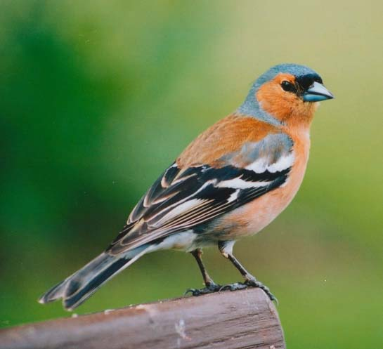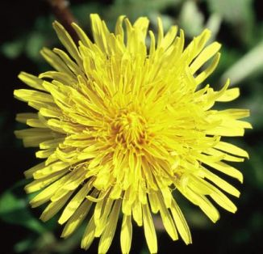
Bígí ag faire amach dóibh/ Look out for these in your garden.
Corp Oideachais
Moltaí: Nascanna le GoNoodle agus Daily PE with Joe the Body Coach ar suíomh na scoile (Homepage.)
Recommendations: Links to Go Noodle and Daily PE with Joe the Body on the homepage of the school website.
Ealaín
Tá go leor smaointe ar fáil ar Twinkl agus Scoilnet (nasc ar homepage suíomh na scoile). Déan cártaí don Cháisc nó pictiúr bunaithe ar an dtéama, An tEarrach.
Lots of ideas are available on Twinkle or Scoilnet (links on the homepage of the school.) Children might like to make Easter Cards for their grandparents or make a picture on the Theme of Spring (see above.)
Ceol
Is féidir éisteacht le Vivaldi’s Spring (From the Four Seasons) ar youtube. Dún do shúile……cén chaoi a mhothaíonn tú ag éisteacht leis an gceol seo. Plé é.
Listen to Vivaldi’s ‘Spring’ (From the Four Seasons) on youtube. Close your eyes and listen……How does the music make you feel? Discuss it.

