18-05-2020
A thuistí,
Ta obair bhaile leagtha amach agam don tseachtain seo ach mar is gnáth ní chaithfidh tú gach rud a chlúdú. Roghnaigh an méid agus gur féidir. Má tá aon cheist aghaibh beidh mé ar fail ar Google Classroom i rith an lae nó is féidir libh ríomhphost a chur chugam ar noirin@scoilnagceithremaol.com.
I have included some suggestions for homework for the children this week. I understand that you may not get around to completing all the activities. Choose what works best for your family. If you have any questions for me I will be available on Google Classroom throughout the day or you can email me at noirin@scoilnagceithremaol.com.
Dé Luain(Monday)
Gaeilge
- Scéal – Bí ag spraoi liom. (Ctrl & Click) (the stories this week are on a Facebook page so children may require supervision while listening).
- séideánsí.ie (Ctrl & Click) – If you click on Áiseanna Eile on the Seideansi website you will find some short books that are suitable for Junior Infants. I recommend reading ‘Céard atá agat’? Practice asking the following question aloud – Céard atá agat? They could answer ‘Tá mó bhróga/mo gheansaí/mo mhála scoile/mo pheann luaidhe agam’, for example. Parents could ask questions and children answer and vice versa.
- Cúla4 ar Scoil have a spoken language lesson this morning(focusing on travel today) that should be suitable for Junior Infants. It will be on TG4 at 10:00a.m & I will attach their timetable at the bottom of this email.
- leighleat.com – Revise a. Listen to the song which can be found by clicking on the musical notes in the centre of the page(over Aindí Ailigeadar). Then allow the children to listen to and look at some words beginning with a. Allow your child to repeat each word. Practice writing a.

Béarla – If you have some extra time this week your child could listen to Jolly Phonics songs on YouTube.
- We will learn w this week. Song – I see the clouds moving, /W/-/W/-/W/. I see the kites flying, /W/-/W/-/W/. I see the trees bending, /W/-/W/-/W/. The wind is blowing strong. It’s sung to the tune of ‘He’s got the Whole World in his hands’. You will find the songs for each letter/sound on YouTube.
- Identify and discuss words that start with w, for example wind, watch, wax, water, wizard, wand, world, wasp, watermelon, wag, wet, web, win, wig, wind.
- Show your child what w looks like. Practice writing w on a page. You may have to draw dots in the shape of w first.
Worldbookonline.com has some stories that I would like the children to listen to. If you press Ctrl & click on my link above(this should bring you directly to the story) or if you click on Early Learning on the website you will find the relevant page. Click on Stories at the top & then click on the skeleton icon. Today I would like the children to listen to ‘Sam starts School’. You can read the story aloud or there is an option for the website to read the book. What or who do you miss the most about school? Draw a picture of your favourite place in our school.
Mata
Uimhir(Number)
- Can you count some Lego pieces or some jigsaw pieces? Maybe another person in your house can lay out small piles of Lego for you to count.
- Practice writing 0-5 on a page or with a chalk outside.

Am(Time)
This week we are going to look at Time in Maths.
- Today I would like the children to explore and look at the differences between day and night.
- Can you draw a picture of night-time and day-time on the same page? You can divide the page in half.
- How do you know that it’s night-time? Is it dark? Can you see the moon or stars? Are the curtains closed? Is anybody in bed?
- How do you that it’s day-time? Is it bright? Can you see the sun? Are children outside playing? Are you doing homework?

Dé Mairt(Tuesday)
Gaeilge
- Scéal – An Gabhar a raibh an Ocras go Deo Air.
- séideánsí.ie – I recommend reading ‘Céard atá agat?’ again today. Practice asking the following question aloud – Céard atá agat? Ask your child to answer the question. You could practice this question at breakfast time. Children could respond with ‘Tá leite(porridge) agam’ or Tá arán(bread) agam’ or ‘Tá ubh(egg) agam’ or Tá bainne(milk) agam’ or ‘Tá calóga árbhair(corn flakes) agam’.
- leighleat.com – Revise d. Listen to the song which can be found by clicking on the musical notes in the centre of the page(over Dónal Doras). What items can you draw that begin with d? Can you draw a doras, doirteal, dubh, dó, donn, dorn, duais, dána, damhain alla?

Béarla
- Revise the w song. Can your child remember any words that begin with w?
- Practice writing w. Ready to Write A – w page.
- If you have time you can do the following activity with your child. Tell your child that you are going to say some words. Some of the words begin with /w/ and other words do not. Tell them they should stamp their feet whenever they hear the /w/ sound at the beginning of a word. Say the following words one at a time, allowing time for your child to respond: wand, wag, tap, wind, job, pot, wonder, woman, pencil, want, will, house.
Worldbookonline.com - Today I would like the children to listen to ‘Going to the Doctor’. You can read the story aloud or there is an option for the website to read the book. Draw a picture of an animal that you would like to have as a pet. Can you describe that animal to somebody in your house?

Mata
Uimhir(Number)
- Continue to count from 1 -10 and from 10-1.
- Practice writing 0-5 on a page.
Am(Time)
- Discuss activities that children would do in the morning(maidin), lunchtime(am lóin), evening(trathnóna) and bedtime(am leapa). In the morning you might brush your teeth or get dressed. At lunchtime you might eat your lunch or do some school work or play outside. In the evening you might eat dinner or watch tv. At bedtime you might put on pyjamas or listen to a story. They could discuss activities for a normal school day or for their days at home.
- Today I would like the children to complete page 36 in Gafa le Mata Nasc Baile. This involves a timetable of the day. There are 4 pictures to draw.
- Can the children guess how long each of the activities they have drawn would take?

Eolaíocht - lesson on Cúla4 ar Scoil this morning as Gaeilge.

Dé Céadaoin(Wednesday)
Gaeilge
- Scéal – Coinín Beag Bocht.
- séideánsí.ie(ctrl & click). I recommend reading ‘Éadaí Liam’ today. Ask your child to practice saying the items of clothing aloud in Irish.
- Cúla4 ar Scoil have a language lesson this morning(reading) that may be suitable for Junior Infants. It will be on TG4 at 10:00a.m.
- leighleat.com – Revise d. Listen to the song which can be found by clicking on the musical notes in the centre of the page(over Dónal Doras). What items can you draw that begin with d? Can you draw a doras, doirteal, dubh, dó, donn, dorn, duais, dána, damhain alla? Can you write 10 d’s?

Béarla
- Revise the w song. Can your child remember the words that begin with w?
- Try writing some small words that begin with w. Call out words such as wag, wig, wet, web, wax, win, wand, wed, & wind slowly. Remind them to listen carefully to the word as you say it slowly twice. They may be able to write the first letter independently. You may have to help after that.
- If you have chalk you could practice writing w with chalk outside.
Worldbookonline.com – I would like the children to listen to ‘Counting with Colourful Food’ today. Draw a picture of 5 apples? What colour could you use to colour the apples?

Mata
Uimhir(Number)
- Continue to count from 1 -10 and from 10-1.
- Practice writing 0-5 on a page or with a chalk outside.
Am(Time)
- Today we will look at the seasons and learn their names – An t-Earrach(spring), An Samhradh(summer), An Fómhar(autumn), An Geimhreadh(winter). Discuss the differences between the seasons.
- What would the weather be like in winter or in summer?
- What happens to leaves and flowers in spring? What happens to leaves in autumn?
- When are lambs born?
- In what season is your birthday?
- Can you draw a picture for each season?

Ceol – Music lesson on Cúla4 ar Scoil on Tg4 at 10:00a.m or it will be available also on the app or website.

Deardaoin
Gaeilge
- Scéal – Scúnc agus Smúirín
- séideánsí.ie – I recommend reading ‘Éadaí Liam’ again today. Children could practice saying ‘Tá bríste agam’, or Tá geansaí agam’. They could practice that sentence for each page in the book.
- Cúla4 ar Scoil have a language lesson this morning(focusing on writing) that should be suitable for Junior Infants. It will be on TG4 at 10:00a.m.
- leighleat.com – Revise i. Listen to the song which can be found by clicking on the musical notes in the centre of the page(over Isabéal Ispín). Then allow the children to listen to and look at some words beginning with i. Allow your child to repeat each word. Can you draw an ispín(sausage), ag imirt(playing), irisleabhar(magazine), im(butter), instealladh(injection), ag ithe(eating) or idirlíon(internet). Practice writing i. Try to write your 5 best i’s today.

Béarla
- Revise the w song. Can your child remember any words that begin with w?
- Practice writing w on a page.
- Children can copy one or all of the following sentences:
The dog can wag.
The pig is wet.
Can I win?
Worldbookonline.com – I would like the children to listen to ‘A Loose Tooth’ today. Have you ever had a loose tooth? Did the Tooth Fairy visit?
Mata
Uimhir(Number)
- Continue to count from 1 -10 and from 10-1.
- Practice writing 0-5 on a page.
Am(Time)
- Today I would like the children to learn the days of the week.
- Page 33 & 34 of Gafa le Mata – Nasc Baile/Scoile has the days of the week and a space for a picture over each day. You should draw a picture of something you would do on that particular day. I would like the children to complete page 33 today.
- Practice saying each day aloud.

Dé hAoine
Gaeilge
- Scéal – Mo Theachín gan Chuma Chaoi
- séideánsí.ie – If you click on Áiseanna Eile you will find some short books that are suitable for Junior Infants. I recommend reading ‘Éadaí Liam’ again today. Can you draw something that you would wear on a very cold wintry day?
- leighleat.com – Revise i. Listen to the song which can be found by clicking on the musical notes in the centre of the page(over Isabéal Ispín). Then allow the children to listen to and look at some words beginning with i. Allow your child to repeat each word. Can you draw an ispín(sausage), ag imirt(playing), irisleabhar(magazine), im(butter), instealladh(injection), ag ithe(eating) or idirlíon(internet). Practice writing i. Try to write your 5 best i’s today.

Béarla
- Revise the w song. Can your child remember any words that begin with w?
- Write your 10 best w’s today.
- Children can copy one or all of the following sentences:
Sam has a wig.
I sat on the web.
The wand is big.
The cat sat on the wax.
Worldbookonline.com – I would like the children to listen to ‘Going to the Dentist’. Can you describe how to clean your teeth? Have you ever been to the dentist? What advice did he/she give you?

Mata
Uimhir(Number)
- Continue to count from 1 -10 and from 10-1.
- Practice writing 0-5 on a page.
Am(Time)
- Today I would like the children to revise the days of the week.
- Complete page 34 in Gafa le Mata – Nasc Baile. What do we call the days that are part of the weekend? Can you remember what day we do Irish Dancing at school? What day did we do gymnastics?
- In what month do you celebrate your birthday?

Stair – lesson on Cúla4 ar Scoil this morning as Gaeilge.
Tir Eolas - lesson on Cúla4 ar Scoil this morning as Gaeilge.
Eile:
Óga Yoga TV on YouTube – directions/instructions are in Irish.
PE with Joe Wicks on YouTube weekdays at 9am but you can visit anytime to view the workout.
10 @ 10 as Gaeilgehttps://rtejr.rte.ie/10at10/, Go Noodle videos http://www.gonoodle.com/
Freeze Dance (Damhsa is fearrlinn - Class favourite)https://www.youtube.com/watch?v=2UcZWXvgMZE
Yoga do Pháistí:http://www.cosmickids.com/
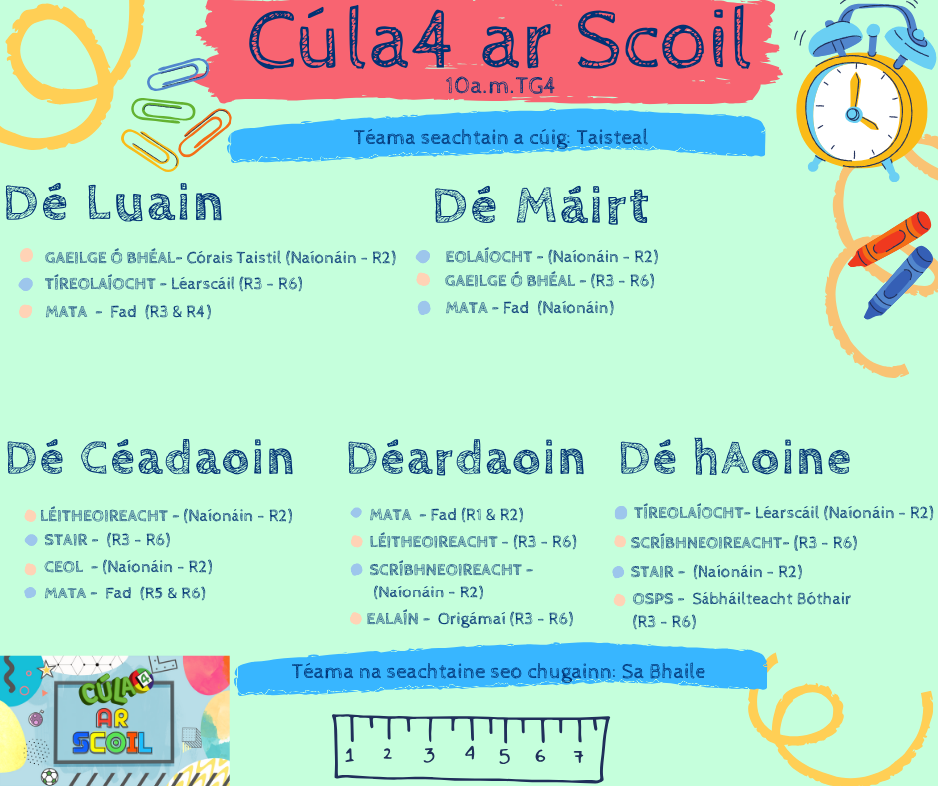

Tugaigí aire dá chéile agus go mbeannaí Dia sibh.
Múinteoir Nóirín

