20-04-2020
A thuistí,
I hope that you and your families are well and are getting through this difficult time we find ourselves in. I have assigned some work for the children for the coming week. I am asking that the children complete the three core subjects of Irish, English and Maths every day. Select what works for you and don’t worry if you don’t get around to everything.
Of course any work that can be completed in any of the other subject areas would be most beneficial.
Music – Practice singing nursery rhymes or Irish songs on songsinirish.com
PE – Play games to practice catching, throwing and kicking a ball, ride bikes, and get plenty of fresh air!
Art – Be creative. I would love to see your creations on your return to school. This would be a great time to use recycled materials to create junk art pieces.
Colouring and cutting activities are very useful for children. Building jigsaw puzzles and playing board games is something that I would also recommend.
Gaeilge
www.leighleat.com is a good website to help your child revise the letters covered in our Irish lessons. If you click on Ceachtanna at the top & then on Fónaic & then on Connacht you will see a list of the letters. The children have learnt a, c, duh, e, g, h, i, m, n, o, p, r, ess, teh, u & l . This website will show you how to pronounce each sound. It also has a song to go with each letter and the children will be familiar with this song. There are also words beginning with each sound if you click the arrow on the right at the bottom.
We will look at f this week. Listen to the song which can be found by clicking on the musical notes in the centre of the page(over Fionn Fliuch). Then allow the children to listen to and look at some words beginning with f.
If you have extra time you can revise any of the sounds covered on leighleat.com. If you mute the sound as you move through the pictures(using the arrow in the right corner at the bottom of the page) your child will get the opportunity to see if they can recall the words as Gaeilge.

Scéal an Lae on YouTube has some suitable Irish stories.
This is a good way to begin an Irish lesson. The children will enjoy looking at the pictures and listening to exciting stories.
Monday – An Garbhán
Tuesday – Béiríní ag Troid
Wednesday – Ciara Cainteach
Thursday – Dinnéar do Toby
Friday – Cití Cearc

Cula4.com is providing lessons that will cover elements of the primary curriculum with different themes each week. Cúla4 ar Scoil begins Monday 20th April at 10a.m. Lessons will be short & I recommend taking part. TG4 will also broadcast an additional schedule before and after Cúla4 ar Scoil from 9:30 a.m. to 11 a.m. each day, which will include programmes with educational themes including ‘Bia Linn’, Ár Scéal, ‘Am Foghlama le Timmy’, ‘Is Eolaí Mé’ and ‘WAC’.
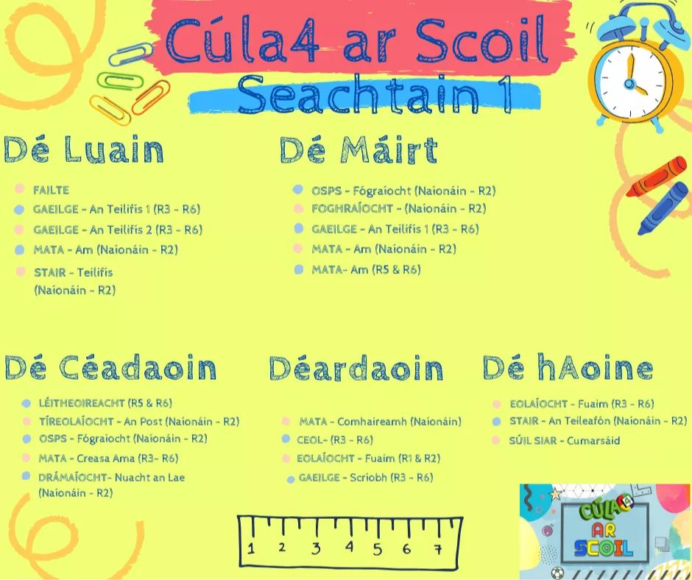

www.seideansi.ie is a useful website. If you are asked to choose your dialect(roghnaigh do chanúint) click on Connachta. Click on Aiseanna Eile and that will bring you to some short storybooks with pictures and sound.
Monday & Tuesday – An Gadaí Beag
Wednesday & Thursday – An Tusa mo Mhamaí?
If you click on class level(Ranganna – Naíonáin Bheaga) you will see 3 options. I recommend trying the “2nd option which is Caith do Léim. Children may need assistance with this initially but it would help them to recognise some common Irish words. There are two stages and i recommend clicking on Céim 1 first.
Continue to listen to the C.D that is available for downloading free of charge – Naíonáin Bheaga Dlúthdhiosca 1. There are lots of songs and poems on that C.D that we have practiced at school and it would benefit the children to be given the opportunity to revise those.
You can also listen to stories and conversations on a downloadable C.D from the same website.
Scéalaíocht do Pháistí Óga:

Béarla/English
- Practice writing s,a,t,i,p,n,c,k,e,h,r,m,d,g,o,u, l. Can your child name something that begins with these sounds? Can your child write this sound/letter if you call it out? If they forget what the letter looks like you can show them and then they can write it down.
- We will learn f this week. Song(to the tune of Old MacDonald) – My friends and I went to the beach with my floating fish. It got a hole....the air came out. /f/,/f/,/f/,/f/ You will find the songs for each letter/sound - www.dailymotion.com/video/x2wpdvv
- Identify and discuss words that start with f, for example fish, fox, feet, fork, feather, face, fan, flower, frog, five, four, fly, friends.
- Practice writing f. Ready to Write A – f page.
- Draw pictures of objects or people that start with f.
www.teachyourmonstertoread.com is a good website to help your child revise the sounds covered in school.

worldbookonline.com is another great resource. Click on Early Learning and then stories. I recommend clicking on the frog and this will provide you with a selection of Fairy Tales.
Monday – Cinderella
Tuesday – The Three Billy Goats Gruff
Wednesday – The Dog and the Bone
Thursday – The Shoemaker and the Elves
Friday – Mulan
I also recommend clicking on the musical note which will provide a selection of Nursery Rhymes and songs. The Alphabet song is there and would be great to listen to daily.
Monday – Yankee Doodle
Tuesday – The Grand Old Duke of York
Wednesday – Little Miss Muffet
Thursday – Hot Cross Buns
Friday – London Bridge is Falling Down

You will also find some stories read aloud on the following websites:
https://rivet.area120.com/read/#/libraryScreen
https://www.storyberries.com/
https://www.worldbook.com/ebooks.aspx
https://stories.audible.com/start-listen
http://www.storylineonline.net/

Children could also practice writing some short sentences:
Sam is a cat.
Sam is fat.
The cat is sad.
The pig is pink.
They can copy the sentences or try to write them when you call them out.
Mataí
Count forward(1-10) and backward(10-1) with your child. Ask them to count various objects around the house. Children can practice writing numbers 1-5 as often as possible.
Introduce your child to 0(náid) this week. Ask them to bring you 0 books/spoons/socks from around the house. Practice writing 0.
Demonstrate full(lán) and empty(folamh), using different containers and also discuss which container holds more(níos mó)/ less(níos lu). Some of these activities could be completed outside if you have an outdoor tap or using sand/soil/compost.
Gafa le Mata, Nasc Baile, Lth 27 & 28.
CJFallon.ie has free access to our Maths book. It’s called ‘Gafa le Mata’ & you will also be able to access the English version which is called ‘Busy at Maths’.

Eile:
Reading stories to your child is an excellent way to help them in their learning.

Óga Yoga TV on YouTube – directions/instructions are in Irish.
PE with Joe Wicks on YouTube weekdays at 9am but you can visit anytime to view the workout.
10 @ 10 as Gaeilgehttps://rtejr.rte.ie/10at10/, Go Noodle videos http://www.gonoodle.com/
Freeze Dance (Damhsa is fearrlinn - Class favourite)https://www.youtube.com/watch?v=2UcZWXvgMZE
Yoga do Pháistí:http://www.cosmickids.com/

Tugaigí aire dá chéile agus go mbeannaí Dia sibh.
Múinteoir Nóirín

