Literacy apps for Android:
Strand | App | Icon | Link | Description
Multiple Strands | Comic Life | 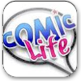 | http://comic-life.en.softonic.com/  (This link must be downloaded) | Comic Life allows you to create a real comic with your own photos and images.
Multiple Strands | Starfall | 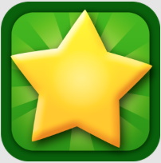 | https://play.google.com/store/apps/details?id=air.com.starfall.more | Contains much of the functionality of the well-loved website.
Multiple Strands | Book Creator | 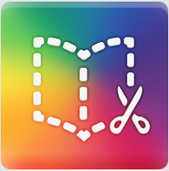 | https://play.google.com/store/apps/details?id=net.redjumper.bookcreator&hl=en | Useful app to allow pupils to create ebooks, using photos or text. Free version is somewhat limited but gives a good taster of what is possible.
Reading | MeeGenius Children's Books | 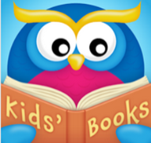 | https://play.google.com/store/apps/details?id=com.meegenius.reader | Your child’s imagination will be captivated by giving them access to lots of read along books. This is a library of digital books for children up to 8 years of age.  All these digital books are available with read along word highlighting, rich illustrations and story narration.
Reading | Mr. Icky Fox |  | https://play.google.com/store/apps/details?id=air.rainbowickymrfox | Mr Icky Fox promotes strong learning and reading in young children.  The book is full of interactive objects which when activated by a child show the object's name as words and sound. Among other features of this book include professional narration, beautiful illustration and animation.
Reading | iStoryBooks | 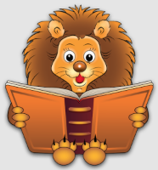 | https://play.google.com/store/apps/details?id=com.infomarvel.istorybooks&feature=search_result#?t=W251bGwsMSwyLDEsImNvbS5pbmZvbWFydmVsLmlzdG9yeWJvb2tzIl0 | Provides popular children’s stories with the option of having them read to the child or the child reading them himself.
Oral Language – Listening / Speaking | Rory's Story Cubes | 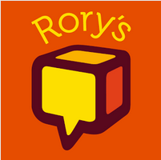 | https://play.google.com/store/apps/details?id=com.thecreativityhub.RSC | Contains multiple images along with 9 cubes with over 10 million different combinations and unlimited stories. Challenge a child to create a story using all 9 face-up images.
Oral Language - Poetry | POETRY from The Poetry Foundation | 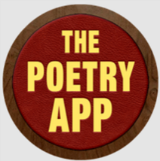 | https://play.google.com/store/apps/details?id=com.mcsaatchimobile.thepoetryapp | The works of T.S. Eliot, Pablo Neruda, Lucille Clifton, Emily Dickinson, and many others are a feature of this App.  Create your own poems and save your favourites. Share your work in Facebook, Twitter and e-mail.
Oral Language – Listening / Speaking | Tellagami | 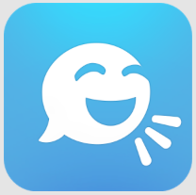 | https://play.google.com/store/apps/details?id=com.tellagami.Tellagami&hl=en | Tellagami allows the user to create a Gami to tell a story. The user can choose a character and background and record his/her voice.
Writing | Write ABC (Free) | 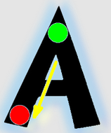 | https://play.google.com/store/apps/details?id=com.kindergarten.MathPreScool3 | A resource for handwriting incorporating the tracing of letters. The process is separated into easy steps accompanied by bright arrows with unique green and red circles signatures where to begin and where to stop tracing.
Writing | Writing Prompts | 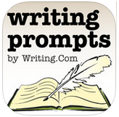 | https://play.google.com/store/apps/details?id=com.writing.writingprompts | Incorporating over 250 scene elements, 400 words, 60 sketches, 10 colours and over 80 genres which can generate millions of prompts for creative writing.
Writing | School Writing learn to Write | 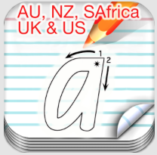 | https://play.google.com/store/apps/details?id=com.project.schoolwriting&hl=en | Though this app has a cost, it is a fully customisable app using audio and video. The fonts are primary school appropriate. Pupils and teachers can trace and record audio.
Spelling | Dropwords | 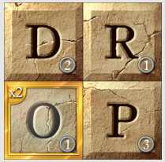 | https://play.google.com/store/apps/details?id=com.eekgames.worddrop&hl=en | Electronic version of Boggle. How many words can you make? What is the longest word that you can make? Great practice for spelling.
Spelling | Spelling Test Free | 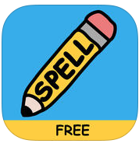 | https://play.google.com/store/apps/details?id=com.funexam.spellingtestfree&hl=en | Pupils and teachers can create their own spelling test, complete with audio. The app keeps score of what answers were correct.
Spelling | Vocabulary Spelling City | 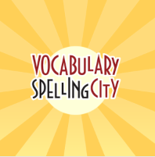 | https://play.google.com/store/apps/details?id=air.com.spellingcity.VocabularySpellingCityAndroid&hl=en | This app contains a number of games promoting spelling. The free version offers 8 different activities and more are available in the paid version.
Spelling | My Spelling Test | 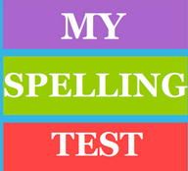 | https://play.google.com/store/apps/details?id=com.ananiya.myspelling | The weekly spelling test and the resource to make you a spelling genius.
Phonics | Jolly Phonics |  | https://play.google.com/store/apps/details?id=com.gilbertjolly.teachphonics.teachers | Using a synthetic phonics approach, Jolly Phonics teaches children the five key skills for reading and writing

